MF1 Demo User Manual

Manual Name：MF1 Demo User Manual
Manual NO ：
Version：V1.0

Total 7 pages
(Including cover)

Compose ZhangYong
Review
Countersign

`

Cilico Microelectronics Co., Ltd
Modifiy record
File No. | Version | Composed By / Modified By | Compose / Modify Date | Modify Reason | Major changes  （Write main Points） | Review By
 | V1.0 | ZhangYong | 2017.03.27 | None | None | ShiLiangYi
Note: When the file is prepared for the first time, write “None” on "Modify Reason" and "Major modifications columns.

Contents

1. Purpose 4
2. Applicable scope 4
3. Install APK 4
4. Open NFC Service 4
5. Launcher App 4
6. Card discover 5
7. Card information 5
8. Card manager 5
8.1 read 5
8.2 write 6
8.3 lock 7
9. Help 8

1 Purpose
Guide how to identify MF1 card, how to read the card data, how to write data to the card, and how to lock card.
2 Applicable scope
Use for the IOT handheld terminals which supports the NFC-enabled .
3 Install APK
First ensure that the device supports the NFC function, Then check whether the device had install this APP, if it was not installed，so install NfcManager.apk。
4 Open NFC Service
First open the “Setting” App ，Then select “more”options of “Wireless & networks”group,，Last select “NFC”options，and open NFC service，and open “Tag reading & writing”。
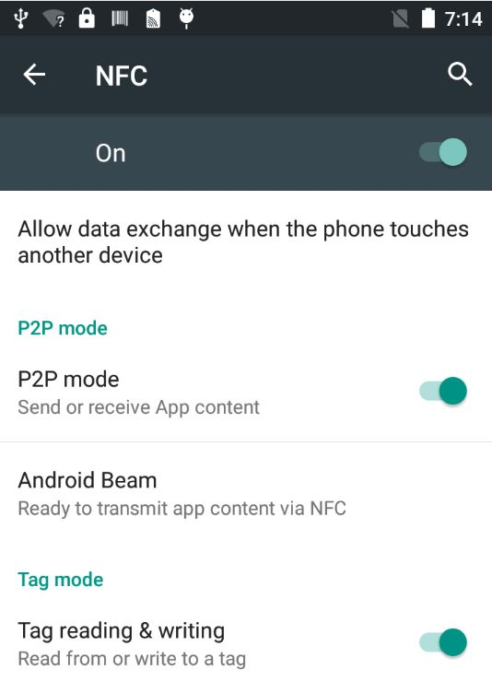

5 Launcher APP
Click the NFC APP Icon to launcher it. 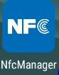
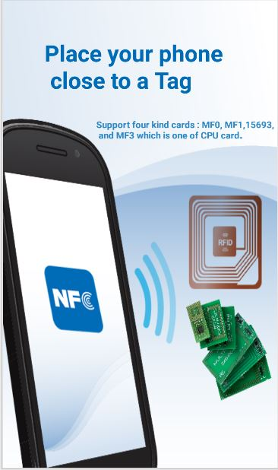
6 Card Discover
Put the MF1 type card into the back of the handheld terminal. After hearing the sound of "toot" , the application interface will automatically pop up, so keep the card not to be moved。
7 Card Infomation
After the card is successfully identified, the basic information of card is parsed and displayed in the top area
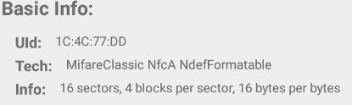
8 Card Manager
8.1 Read
8.1.1 Read single Sector
First select the Key type, and input 6-byte hexadecimal access password of the sector (default as ffffffffffff), then select the access to the sector No., and finally click the "read" button, the results will be displayed in the bottom information area.
8.1.2 Read single block
First select the Key type, and input 6-byte hexadecimal access password of the sector (default as ffffffffffff), then select the access block No., finally click the "read" button, the results will be displayed in the bottom information area.
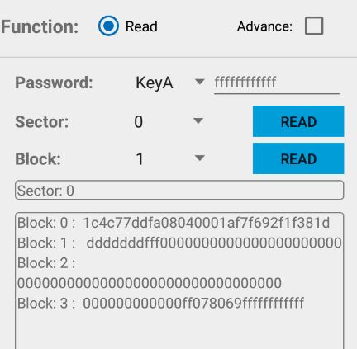
8.2 Write
8.2.1 Show Write Function
First select the "Advanced ", then select "write" radio button, and you can see the interface of write function
8.2.2 Write One Sector
First select the Key type, and input 6-byte hexadecimal access password of the sector (default as ffffffffffff), then select the sector No. , and input the maximum 48 bytes hex data , and finally click "write sector", success or failure will be shown below.
8.2.3 Write one Block
First select the Key type, and input 6-byte hexadecimal access password of the sector (default as ffffffffffff), then select the block No., and input the maximum 16 bytes hex data, and finally click "write block", success or failure will be shown below..
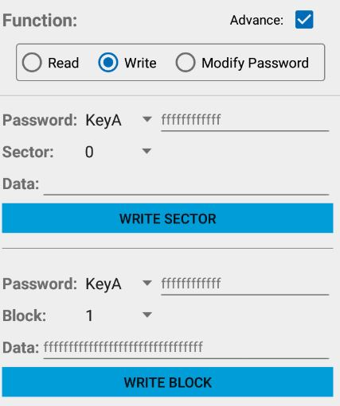
8.3 Modify Password
8.3.1 Show Modify Password Function
First select the "Advanced ", then select "Modify Password" radio button, and you can see the interface of write function
8.3.2 Modify Password
First select the password type and input 6 bytes hex password, then select sector No., Next select the key type, and input the new 6 bytes hex password, and finally click the "modify password" button, success or failure Will be shown below.
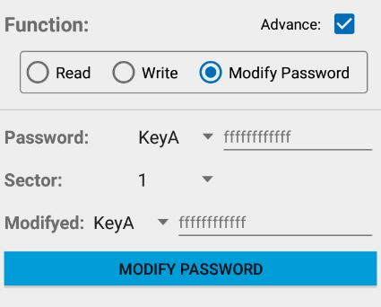
9 Help
Click the upper right corner of the icon, enter the help interface, which describes the MF1 card basic information, as well as some operating instructions.

